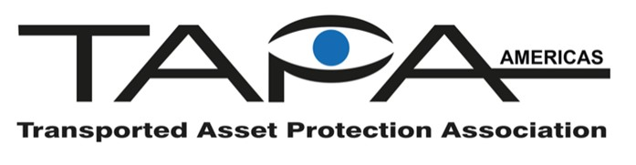
LE Grant Program: Application

The purpose of TAPA Americas’ Law Enforcement Grant Program is to support law enforcement agencies through education and training, thereby enhancing their ability to prevent and reduce cargo theft. Please complete this form and return it to the TAPA Americas Executive Director no later than 60 days prior to the event.

Applicant Information:
Name:
Organization/Company:
Email Address:
Business Phone:
Cell Phone:
Grant Purpose:
Name of the conference, training event, and/or purpose of funding request:
Detailed description of the training, conference, event:
Explain the audience of the event and the targeted attendees:
Explain how the grant will advance TAPA’s mission:
Explain anticipated measurable outcomes, objectives, or results:
Provide an estimate of total funding needs:
Have you applied for grant funding from TAPA before?
Allocation of Funds:
Payee (please include w-9):
Mailing Address:
Contact Person for event:
By signing below, I agree that I have reviewed and agree to the policies and procedures set forth in the TAPA Americas LE Grant Program.
Signature: | Date:

